TITLE

Mario Rossi (1), Paolo Bianchi (2)

(1) Tenova S.p.A., Via Gerenzano 58, 21053 Castellanza, Italy;
(2) Dalmine S.p.A. (Tenaris S.A.), piazza Caduti 6 Luglio 1944 1, 24044 Dalmine, Italy;

Abstract
1000 characters
Without figure / tables

Main results
Up to reach 2 page

Reference [1]

Tables format

CHEMICAL ANALYSIS
CaO [%] | Al₂O₃ [%] | SiO₂ [%]
40-60 | 15-30 | 5-15
Tab. 1 - ……….
Figure format

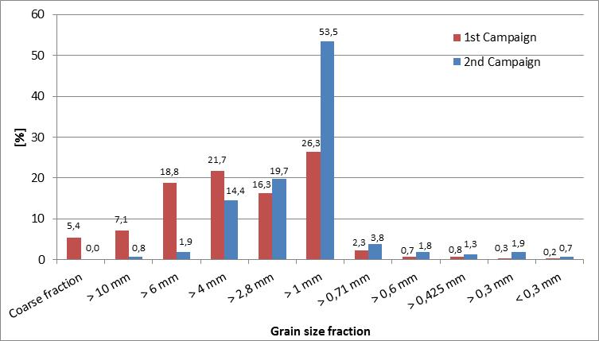
Fig. 5 - ……….

References
- ……….
- …………

